# One Tail test and Two tail test

E.G. Colleges in Karnataka have an 85% placement rate. A new collage was recently opened, and it was found that a sample of 150 students had a placement rate of 88% with a standard deviation 4% does this collage has a different placement rate.

For this we will do 2 tailed tests.

Significance value is ∞ = 0.05

Here mean is 85%.

Find two tail test or one tail test.

Value can be greater than 85 or less than 85. So, this test is tow tail test. Because new collage placement rate may fall in left 2.5% or right 2.5 % region. Now we are going to check whether it is less than 85 or greater than 85. This becomes two tail test.

Does this collage has a different placement rate ?

95

2.5 mean 85 2.5

In the same question

Does this collage have a placement rate greater than 85%?

In this context, this will be one tail test and that will be in righthand.

95%

5%

85%

In same question if is less than 85%

95% This will be one tail test left.

5%

85%

3 Confidence Intervals if ∞ = 0.05

Finding this value is called confidence intervals.

Point estimate

The value of any **statistic** that estimates the value of a **parameter**.

In inferential stats

Sample ----------------🡪 Population

Mean Mean (estimation mean of population

ẋ µ

2.9 3 (In this case if x bar is 2.9 than estimation mean of population may be greater than 2.9 or less than 3.

Confidence Intervals

Point Estimate +/- margin of error

Q On the quant test of CAT Exam, the standard deviation is known to be 100. A sample of 25 test takes has a mean of 520 score.

Construct a 95% CI about the mean?

Give = Population standard deviation ճ = 100

Sample size = n = 25

Significance value ∞ = 0.05 ( 1- 0.95 =0.05)

Mean ẍ = 520

520

2.5 mean 2.5

Find the value of this points which is called confidence interval.

Notes:

1 Population std is given. We apply the test = Pont Estimate +/_ margin of error.

Pont Estimate +/_ margin of error



2 Normally Sample size is n≥ 30.

To do Z test (Z score) above two conditions must be. (Population Std given, and Sample size is n≥ 30).

Just for example

Upper bound = ẍ + z 0.05/2 100/√25= ẍ + z 0.025 100/√25 = 520 + 1.96 (20) = 559.2

Lower bound = ẍ - z 0.05/2 100/√25 = ẍ -z 0.025 100/√25 = 520 – 1.96(20) = 480.8

z 0.025

1-0.025 = 0.975

See Z table of 0.975 = 1.96 from Z table

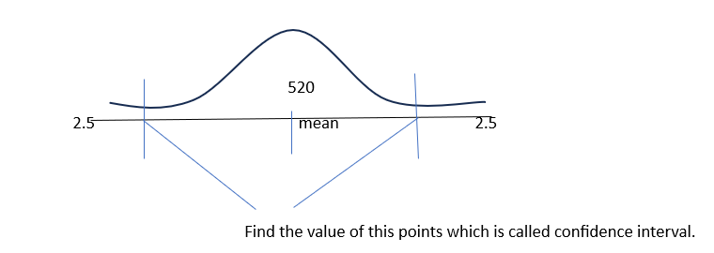

480.8 559.2

If the value falls between 480.8 to 559.2 than accept Null hypothesis, if not then accept alternat hypothesis

Stat Interview question

Find the average size of sharks throughout the world.

Assume

ẍ =?

Significance value ∞ = 0.05

Sample size – n =?

Population standard deviation ճ =?

Question

On the quant test of CAT exam, a sample of 25 test takers has a mean of 520 with a standard deviation of 80. Construct 95% confidence interval about the mean?

Answer,

Given,

N=25

ẍ= 520

s= 80

∞ =0.5

Conditions,

Here population SD is not given in this context we use t-test.

Formula,

Point Estimate +/- Margin of Error.

In this context Margin of Error formula will be changed.

ẍ +/- t∞/2 (s/ -> Standard Error.



Upper bound = ẍ + t 0.05/2(s/

Degree of Freedom = n-1 = 25-1=24

Check T table.

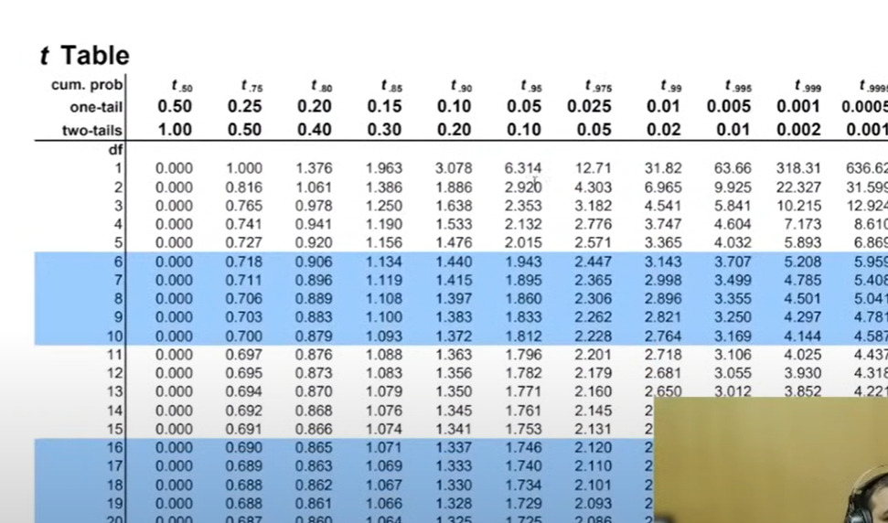

T0.05/2= 2.064

= 520 + 2.064(80/5)

=553.024

Lower bound = ẍ -t0.05/2(s/

= 520 – 2.064(80/5)

= - 486.976

486.97 <-> 553.024 CONFIDENCE iNTERVAL



# Z- Test

One Sample Z-test

Conditions for Z-test

1 Population sd is given.

2 Sample size n 30

Hypothesis testing

In the population, the average IQ is 100 with a sd of 15. Researchers wants to test a new medication test to see if there is positive or negative effect on intelligence, or no effect at all. A sample of 30 participants who have taken the medication has a mean of 140. Did the medication affect the intelligence? And 0.05 (Confidence Interval = 95%)

Answer,

1st how to perform hypothesis testing.

Steps,

1 Define Null Hypothesis.

Ho = µ =100 (mean IQ is equals to 100, Alternate is mean is not 100.)

2 Define alternate Hypothesis. H1, u 100.

3 State Alpha 0.05.

4 State Decision Rule

0.05. and this will be two tail tests.

2.5 95 2.5

-1.96 +1.96

Need to find the both value from Z-table = 1-0.025=0.975

1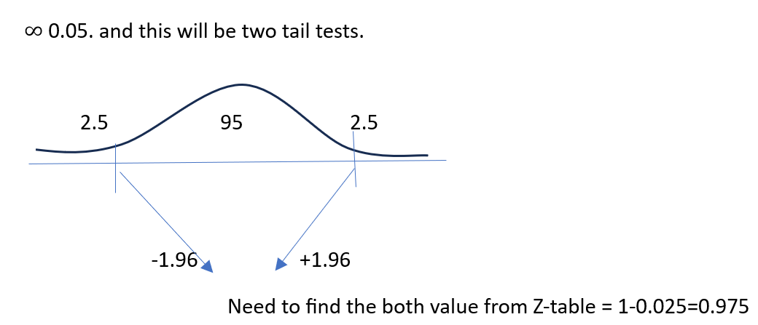

Result value should be inside the -1.96 to +1.96

5 Calculate Z-test statistics.

Z= ẍ-µ/{ճ√n } {ճ√n standard error for huge data}

Z= 140-100/15√30 = 14.60

State out Decision 14.60 > 1.96

Therefore – If Z is less than -1.96 or greater than 1.96, reject the null hypothesis.

Next Question, Did the Medication improve the intelligence or decrease?

By the state of decision. Its greater than 1.96 so, medication improved the intelligence.

Let’s suppose if the Z- value is -0.2

State out decision -0.2 < 1.96 – Decrease the intelligence.

Let’s suppose in above question Mean is 110

New Question whether null hypothesis is accepted or rejected?

2 One Sample t-test

Let’s recall, whenever we have population standard deviation we use Z-test.

If population standard deviation is unknown, we will use t-test.

Question

Population the average IQ = 100

n=30, ẍ=140, s= 2

Did the medication affect intelligence?

∞ 0.05

Answer

Step 1 - H0 =? when µ = 100

Step 2 - H1 =? when µ 100

Step 3 – Calculate the degree of freedom.

n-1=30-1 =29

Step 4 – State Decision Rule

∞ 0.05

2.5 95% 2.5

What is this value of this points?

-2.045 +2.045

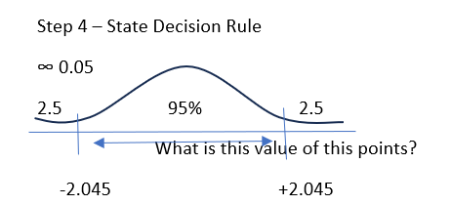

Find the value of degree of freedom 29 from the T table is 2.045.

5 Step5 T-Test

ẍ =140; µ=100; s=20; n=30

T=ẍ-u/s/√n = 10.96

T=10.96 > 2.045 which means we reject null hypothesis.

P Significance value which conclude Increased the intelligence.

Reject the Null Hypothesis. Accept the alternative hypothesis.

# Real World Problem / Scenario {Interview Standard Chartered bank}

Bank want to open - > ATM Machine Area.

Try to solve yourself.?????